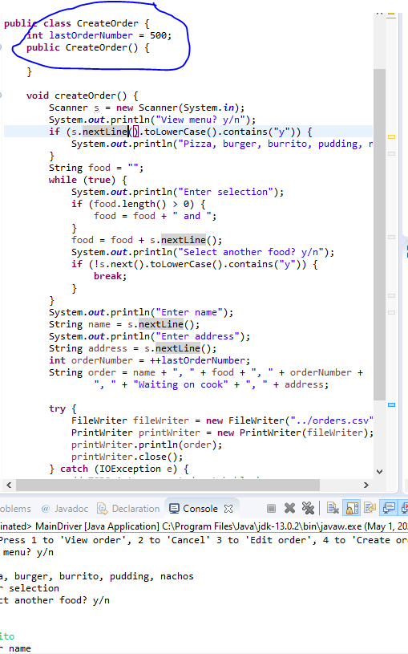

The CreateOrder object keeps track of the next order number to generate using an instance variable, so only one instance of it may be created. It is an example of the Singleton pattern.